FIRST Robotics Team 399 Eagle Robotics
2012 Software Test Plans

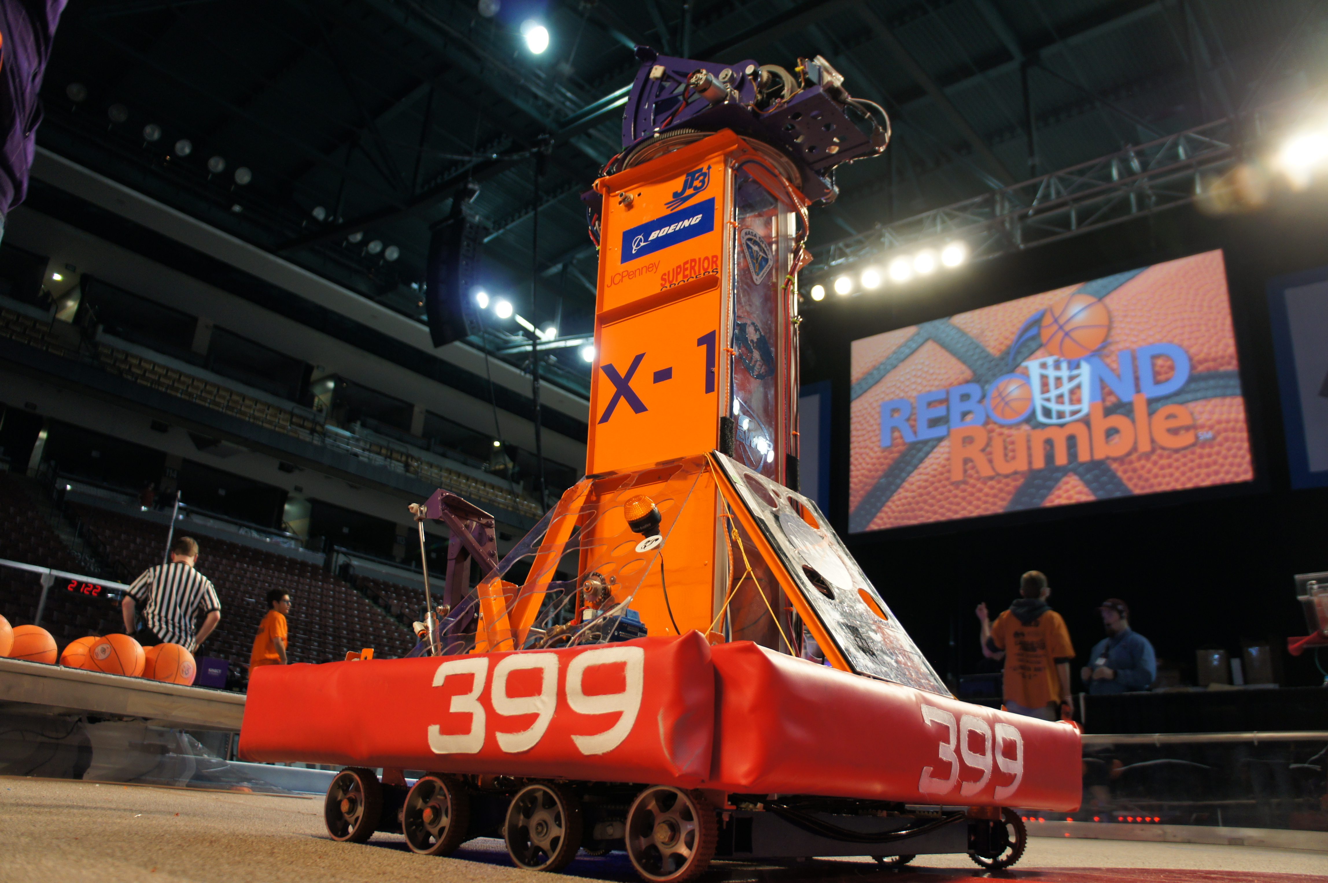
By Jeremy Paul Germita
Summer 2012
Revision 1.0: 6/6/2012
Abstract
This document outlines various test plans for the newly revamped code for FIRST team 399 Eagle Robotics' 2012 Competition Robot, X-1. These test plans have been prepared for various situations such as first boot, pre/post match, and individual mechanism tests.
Contents
- First Boot Test Plan
- Individual Mechanism Test Plans
  - Intake
  - Drivetrain
  - Turret
  - Shooter
  - Vision
- Situational Test Plans
  - First test at competition / demonstration
  - Pre/Post Match
Section I: First Boot Test Plan
About:
This plan outlines the first test after downloading the newly revamped code. It contains instructions on what values to test for and tune. While following the steps in this plan, it is recommended to halt the test and fix any issues encountered.
Prerequisites:
- Robot Wiring has been redone or is in a working state X____
- Robot Mechanisms are complete or in a working state X____
- Code has been downloaded into robot X____
- Fresh battery has been installed into robot X____
- Loose Debris and/or Tools have been removed from robot X____
- All Electrical and pneumatics connections are good X____
- Robot is on blocks X____
Plan:
- Download code to robot X____ Notes: _______________
- Put Robot into teleop X____ Notes: _______________
- Test drivetrain controls
  - Left drive – high gear X____ Notes: _______________
  - Right drive – high gear X____ Notes: _______________
  - shift, hold in low gear X____ Notes: _______________
  - Repeat 3.a and 3.b in low gear X____ Notes: _______________
- Test Intake
  - Run Intake belt – intake direction X____ Notes: _______________
  - Run Intake belt – output direction X____ Notes: _______________
  - actuate dropper down X____ Notes: _______________
  - repeat 4.a and 4.b with dropper down X____ Notes: _______________
  - Repeat 4.a – 4.d with a ball X____ Notes: _______________
- Test Turret
  - Test turret position input X____ Notes: _______________
    - Drive turret to both limits X____ Notes: _______________
  - Tune PID constants or setpoints
as necessary X____ Notes: _______________
- Test Shooter
  - Actuate hood up and down X____ Notes: _______________
  - Test shooter speed input X____ Notes: _______________
  - Repeat 6.a – 6.b with ball X____ Notes: _______________
  - Tune PID Constants and setpoints as
necessary X____ Notes: _______________
- Test Vision
  - Check to see if light ring is on X____ Notes: _______________
  - Check camera feed X____ Notes: _______________
- Test Auto Shoot
  - Run command X____ Notes: _______________
  - Feed ball in and run X____ Notes: _______________
  - Tune as necessary X____ Notes: _______________
- Test Auto Shooter Speed
  - Run Command X____ Notes: _______________
  - Vary distance between camera
and target X____ Notes: _______________
  - Tune constants in the function as
necessary. X____ Notes: _______________
- Test Auto Aim
  - Test various setpoints X____ Notes: _______________
  - Test new tracking algorithm X____ Notes: _______________
  - Tune setpoints and tracking
algorithm constants as necessary X____ Notes: _______________
- Test Auto Drivetrain
  - Test autobalance routine X____ Notes: _______________
  - Implement and test distance
driving routine X____ Notes: _______________
  - tune constants as necessary X____ Notes: _______________
- Test Autonomous
  - Test file loading X____ Notes: _______________
  - Test sample file X____ Notes: _______________
  - Fix any issues encountered X____ Notes: _______________
- Repeat 1 – 12 on floor
Section II: Individual Mechanism Test Plans
About:
This section will outline the various test plans for all mechanisms individually. For brevity and consistency in the sections following this one, they will refer back to this section.
Prerequisites:
- Robot Wiring has been redone or is in a working state X____
- Robot Mechanisms are complete or in a working state X____
- Code has been downloaded into robot X____
- Fresh battery has been installed into robot X____
- Loose Debris and/or Tools have been removed from robot X____
- All Electrical and pneumatics connections are good X____
- Robot is on blocks X____
A: Intake
- Run Intake belt – intake direction X____
- Run Intake belt – output direction X____
- actuate dropper down X____
- Repeat 1 – 4 with dropper down X____
- Repeat 1 - 4 with a ball X____
Questions to ask:
    - Are victor PWM and power connections secure?
    - Is the victor status LED blinking as expected?
    - Are solenoid connections secure?
B: Drivetrain
- Left drive – high gear X____
- Right drive – high gear X____
- shift, hold in low gear X____
- Repeat 3.a and 3.b in low gear X____
Questions to ask:
    - Are Jaguar CAN and power connections secure?
    - Are solenoid connections secure?
    - Are the Jaguar lights blinking as expected?
    - Is the battery voltage good?

C: Turret
- Test turret position input X____
  - Drive turret to both limits X____
- Tune PID constants or setpoints as necessary X____
Questions to ask:
    - Are Jaguar CAN, power, and sensor connections secure?
    - Are the Jaguar lights blinking as expected?
    - Is the battery voltage good?
D: Shooter
- Actuate hood up and down X____
- Test shooter speed input X____
- Repeat 6.a – 6.b with ball X____
- Tune PID Constants and setpoints as necessary X____
Questions to ask:
    - Are Jaguar CAN, power, and sensor connections secure?
    - Are solenoid connections secure?
    - Are the Jaguar lights blinking as expected?
    - Is the battery voltage good?
Vision
- Check to see if light ring is on X____
- Check camera feed X____
Questions to ask:
    - Are camera power and ethernet connections secure?
    - Are light ring connections secure?

Section III: Situational Test Plans
About:
This section will outline the various test plans for various situations. It aims to provide guidance in what to test for in the given situation.
A. First Test at a Competition / Demonstration
This plan should be used upon first arrival at a competition or demonstration after any repairs. It is used to provide a baseline of the robot's status and readiness for match play or demonstration. As with all test plans, issues should be rectified as encountered.
Plan:
- Install a good battery into robot and power on X____
- Test all mechanisms as listed in section 2. X____
  - Test any modified mechanisms multiple times X____
- Test any changes to code thoroughly X____
B. Pre / Post Match
This plan should be used as necessary to test the robot's readiness for the upcoming match or assess any damage or issues that may have arisen in a previous match. As with all test plans, issues should be rectified as encountered.
Plan:
- Do not change battery until after test X____
- Check all electrical connections X____
- Test all mechanisms as listed in section 2. X____
  - Test any modified mechanisms multiple times X____
- Test any changes to code X____
- If the battery is suspected to be the source of any issues, change the battery and repeat steps 1 – 3 as desired
- If post match where a mechanical failure occurred or damage is suspected, check and test any affected mechanisms and rectify encountered issues.
- If post match where an electrical, software, or communications failure is suspected:
  - Recheck all electrical connections, especially
those suspected of failure. X____
  - Review software on robot X____
  - Review Driver Station Logs X____
  - Review with FTA about issue X____

